RESUME

S. PRASANTH Prasanthmoses712@gmail.com
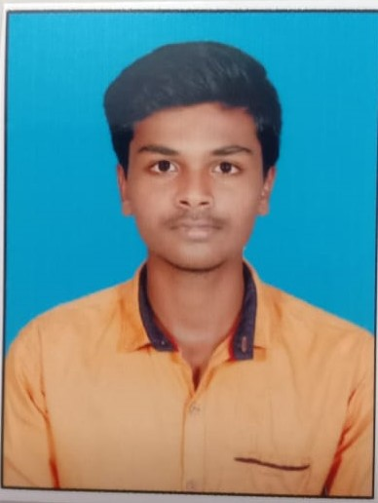

S/O: Selvam
43, Nethaji Nagar 2nd street
Hasthinapuram,
Chrompet
Chennai-64

OBJECTIVE

Highly motivated quick learner, team player and success-oriented professional seeking a challenging position to contribute my skills and knowledge in advanced technologies.
EDUCATIONAL QUALIFICATION

COURSE : B.B.A (Business Administration)
INSTITIUATION : MADRAS CHRISTIAN COLLEGE, TAMBARAM
(AUTONOMOUS)
YEAR GRADUATED : 2022
PERCENTAGE : 62 %

QUALIFICATION | INSTITUATION | YEAR OF PASSING | PERCENTAGE
SSLC | ZION MATRICULATION HR.SEC.SCHOOL,  SEMBAKKAM | 2017 | 79.6%
HSC | ZION MATRICULATION HR.SEC.SCHOOL,  SEMBAKKAM | 2019 | 64%

EXPERIENCE

WHEEL INDIA LIMITED (PADI)
INTERNSHIP AND PROJECT WORK
Project Topic: A Study on “Implementation of Employees Safety and Welfare Measures”

SKILL SUMMARY

TALLY + GST COURSE COMPLETED IN FITA ACADEMY
PERSONAL STRENGTH

      - Confident, Optimistic, Friendly, Managing power,
      - Good team player
      - Leadership quality
      - Punctual
      - Good communication skill.
ACHIEVEMENTS&AWARDS

SUBJECT TOPPER IN BUSINESS MATHEMATICS
PERSONAL PROFILE

Father’s Name : Selvam
Sex : Male
Nationality : Indian
Religion : Christian
Date of birth : 10.11.2001
Marital Status : Single
Languages Known : Tamil and English
Mobile no : 9840845035

DECLARATION

I hereby declare that the details furnished above are correct to best of my knowledge and belief .
THANKING YOU
Place:
Date: Signature
( S.PRASANTH )

